User Manual
<Fingerprint Recognition>

Supervisor: Nigel Whyte
Student: Dayu Chen
Student ID: C00131022
Submit date: 2011-4-11

Contents
1. System Required 1
2. Application Installation 1
3. Function Instructions 2

1. System Required
This application is corss-platform. Please make sure your computer have installed the new version Jave Runtime Environment (JRE). If you have no JRE, you can get JDK1.6 from this application’s CD or Download it from the internet.

Suggestion Environment:
Operating System: Window XP
Running Environment: JRE6

2. Application Installation
This application does not need to install. Just copy the application folder (FRSystem folder) to your computer. Any directory is fine. This application do not need to uninstall too, just delete the folder is ok.
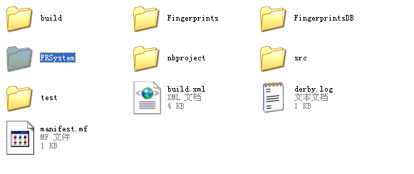

Next, open FRSystem folder, you can see a jar file call FingerprintRecognition.jar. Double click it, and then you can access this application.
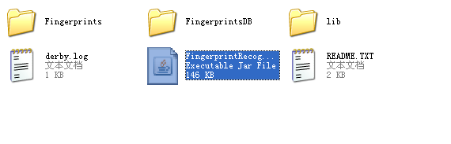

3. Function Instructions
This part introduces how to use this application to access the function. There will be a few Chinese characters in the following figure. This is depending on the Operating system Language, if it is running in English version operating system, these few Chinese character will become English.

3.1 Import Image
The first step you need to import two images, one is input image and another is template image. You can choose them will radio button, and then click button to access import image dialog window.
Choose it

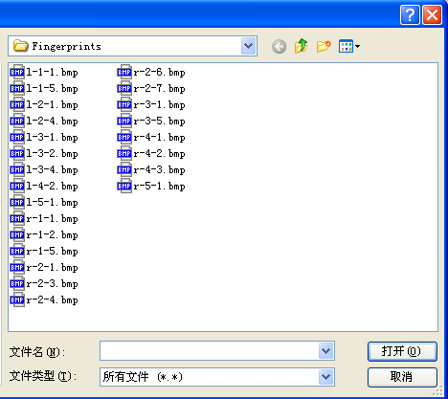
OK button is in here
Choose one image and click “OK” button. After that you can import an image into application. The original import image will be showed at first. Make sure you import the input image and template image both, and then you can go to de preprocessing part.
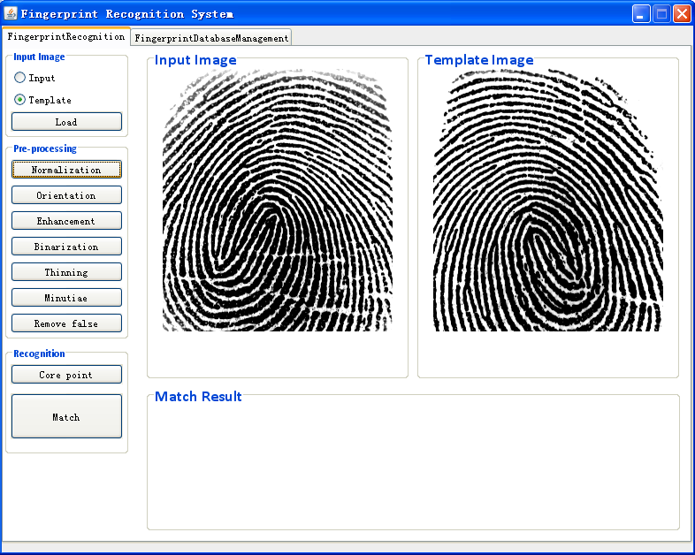

3.2 Normalization
Click the normalization button; you can start to do preprocessing. All the preprocessing buttons are toggle button can mark which step you stay in. The input image and template image will do the preprocessing at the same time. You need to click each button one by one and cannot go back the earlier step.
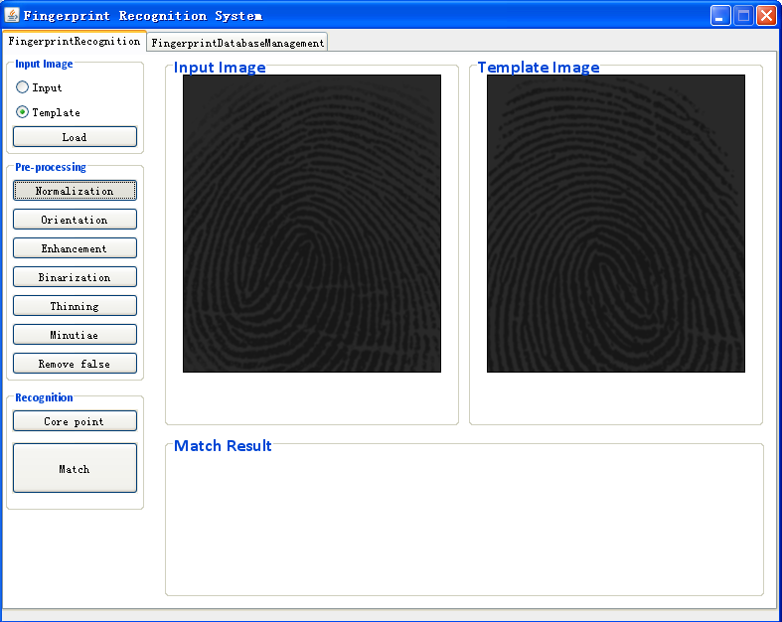
3.3 Orientation Estimation
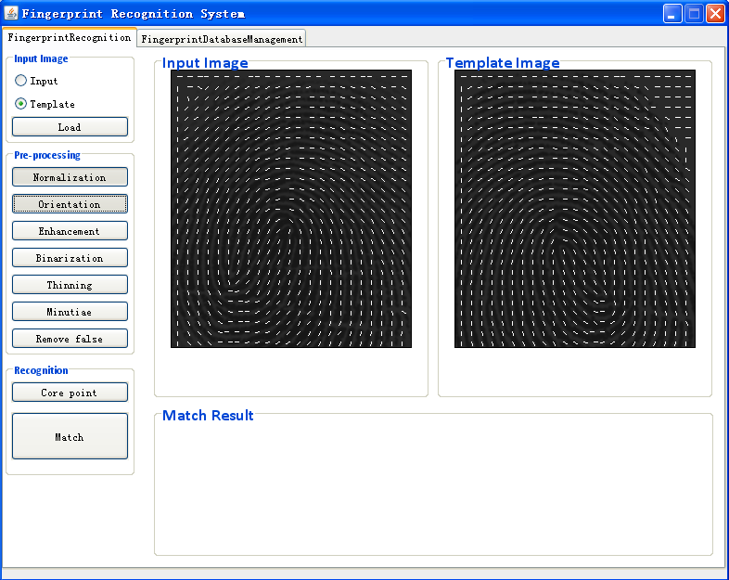
3.4 Image enhancement
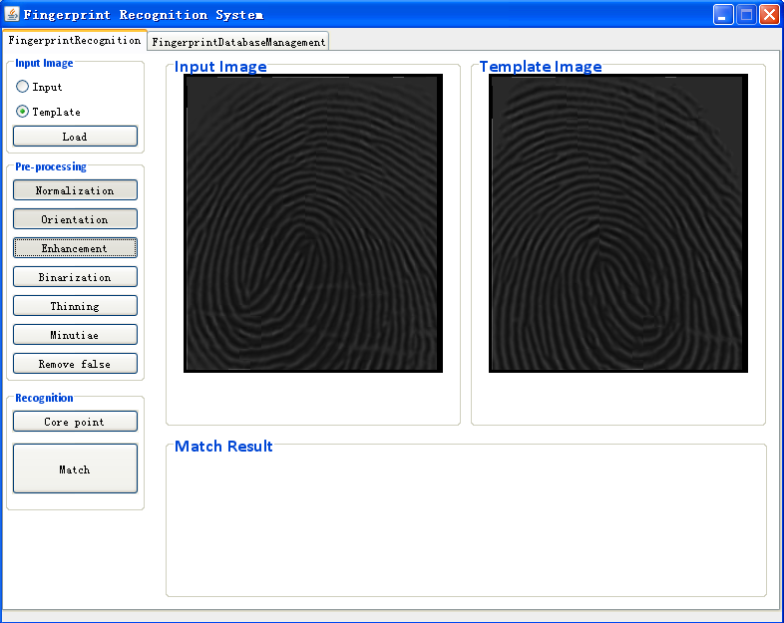
3.5 Binarization
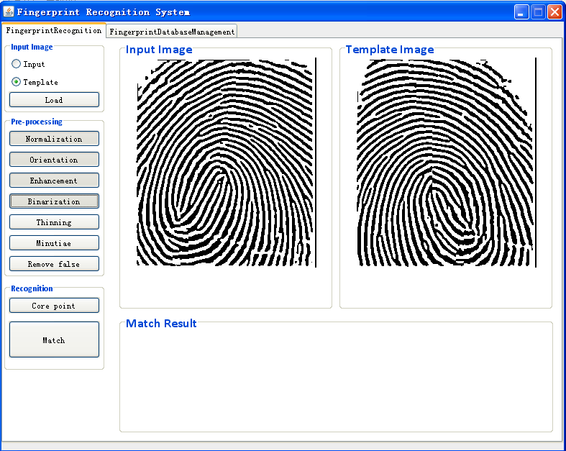

3.6 Thinning
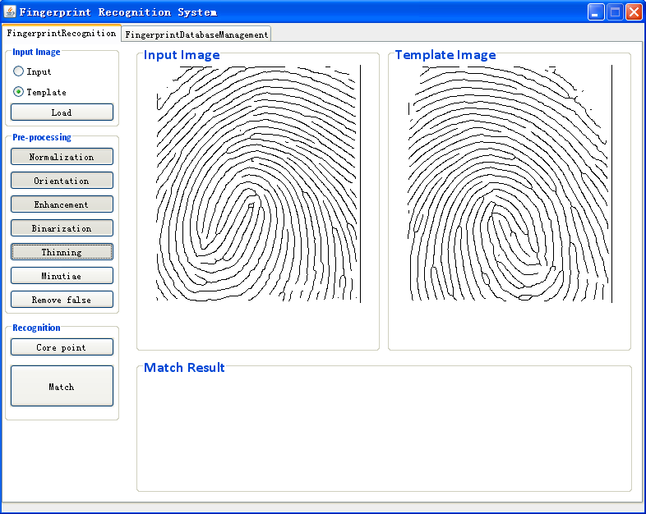
3.7 Minutiae Extraction
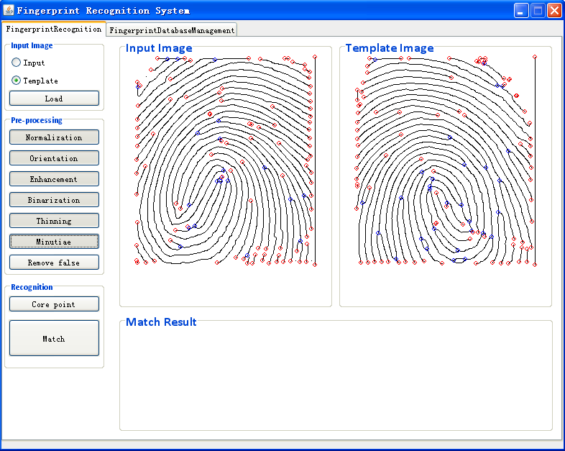
In minutiae extraction, ridge ending will be mark with red circle, and bifurcation will be mark with blue circle. Next step is remove false minutiae.

3.8 Remove False Minutiae
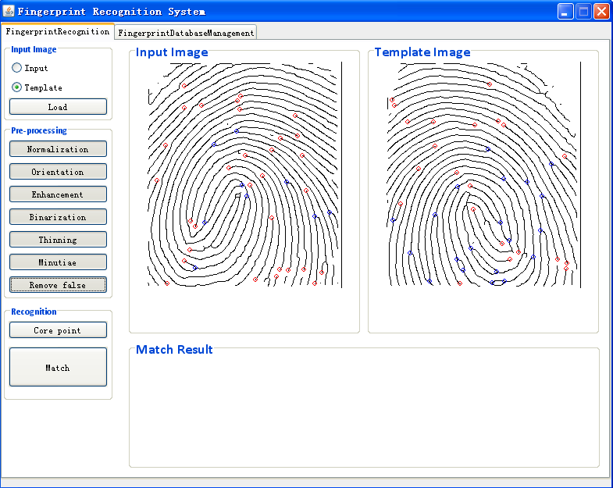
Remove false minutiae is the last step in preprocessing, it can remove most false minutiae. Next you can detect the core point by click the button. The core point will be mark using a bigger cyan circle.

3. 9 Match
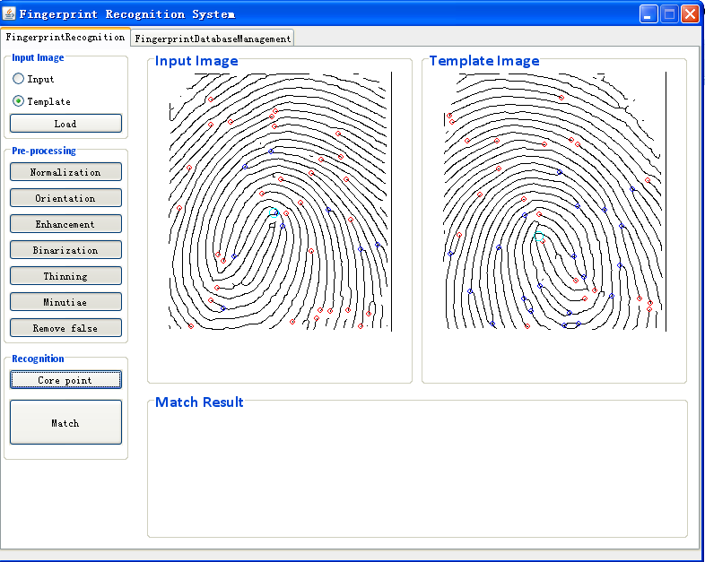
Core pint in image
After the cores have been detected, you can math these two images by click the 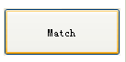button. You cannot go to the match stage without core point detection. The match result will display in the “Math Result” panel.
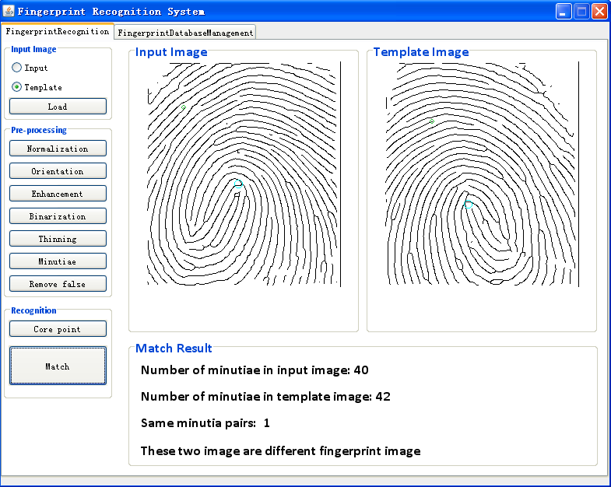
From this result, you can know these two examples are not the same fingerprint image. The following image will show the example match in two fingerprints which are the same.
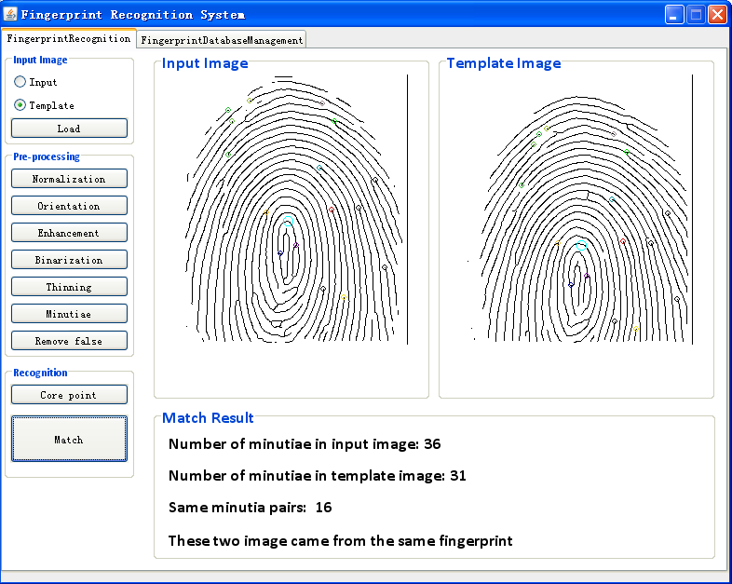
Each same pair minutiae will be mark in the same color, and the minutiae which do not matched will be removed.

3.10 Database Management
You can Access this function by choose the “FingerprintDataBaseManagement” Tab at the top of the window.
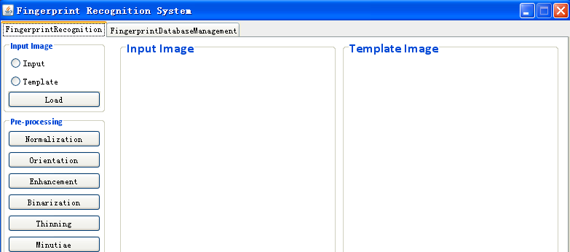
Here

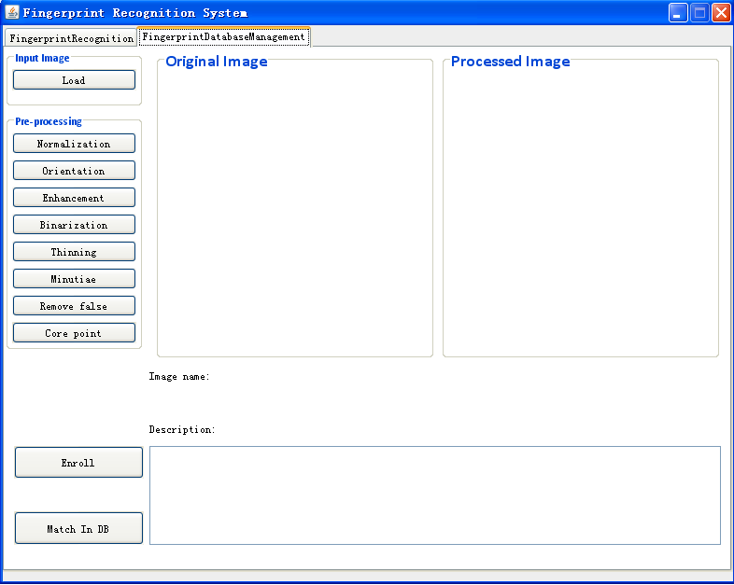
The first several steps are like the function which I introduced before. You need to import image first, but in this function, you only need to import one image, the original image will display in the left panel, and the processed image will display in the right panel. The same to before, you also need to do the pre-processing before enroll/match fingerprint image in database.

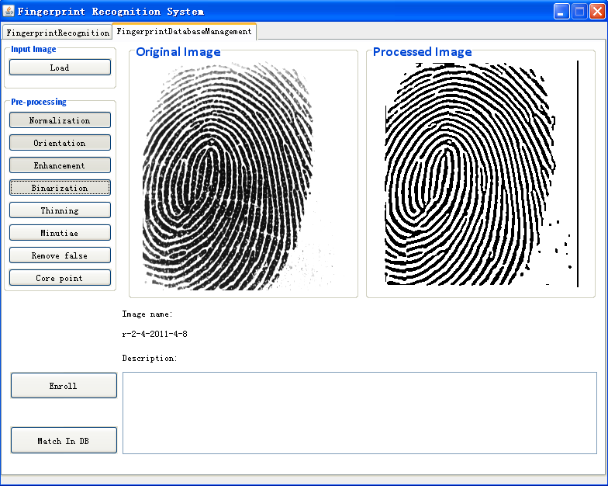
This is an example which shows an image is in preprocessing. An image name will be allocated when an image has been imported. After detect a core point, you can enroll/match this image in to database.

3.10.1 Enroll image in to database
Before enrolling an image into database, you can add some description for it. For example this fingerprint belongs to whom.
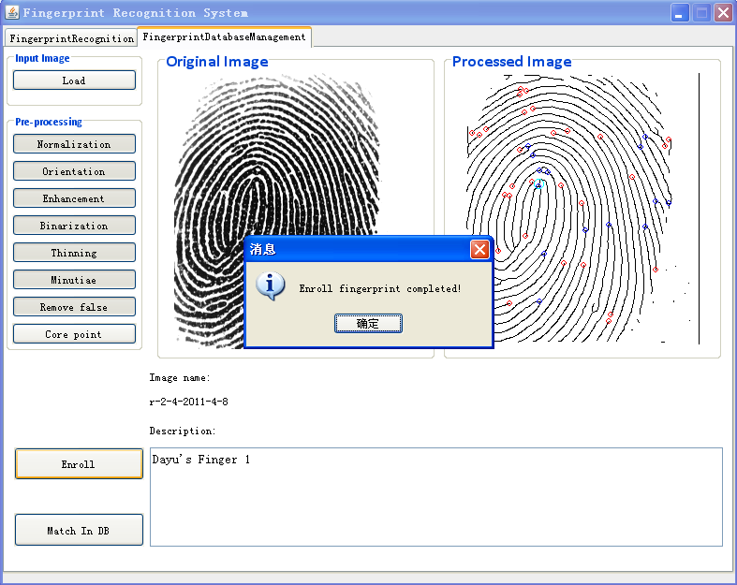
All the fingerprint minutiae will be sorted as a feature vector and the record into database.

3.10.2 Match in Database
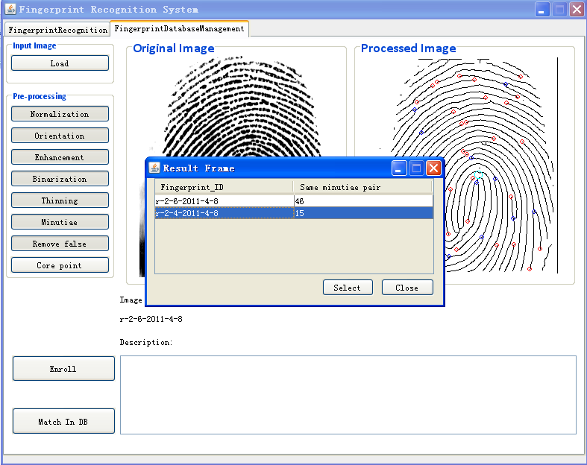
After an image pre-processing, it also can be matched in database.
After matched, the similar result will be generated in the same list, shows to user how many similar pairs in each image. User can select on to check, delete or update description.
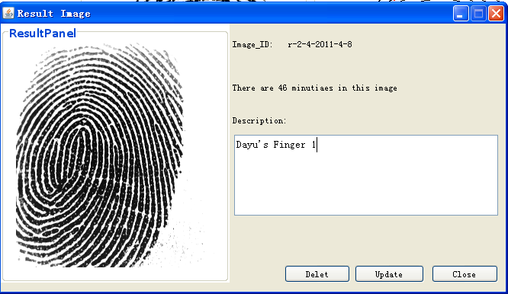

When user finished delete or update, System will provide a window to tell user database operation is completed.

